# 迁移步骤过程

# 第一部分查看数据基本信息

## 一、查看原数据库信息

### 1.查原库oracle对象

select object_type,count(*) from dba_objects where owner='INFODBA' group by object_type;

1 SEQUENCE 318

2 PROCEDURE 3

3 PACKAGE 1

4 PACKAGE BODY 1

5 LOB 209

6 TRIGGER 100

7 TABLE 4001

8 INDEX 7150

9 VIEW 284

10 FUNCTION 9

11 JOB 2

### 2.查看原库每张表的大小和记录

select table_name,round((num_rows * avg_row_len) / 1024 /1024,2) AS table_size_mb,num_rows from all_tables where owner = 'INFODBA' and num_rows is not null order by 2 desc;



### 3.查看表空间和使用率

select total.tablespace_name,

round(total.MB, 2) as Total_MB,

round(total.MB - free.MB, 2) as Used_MB,

round((1 - free.MB / total.MB) * 100, 2) || '%' as Used_Pct

from (select tablespace_name, sum(bytes) / 1024 / 1024 as MB

from dba_free_space

group by tablespace_name) free,

(select tablespace_name, sum(bytes) / 1024 / 1024 as MB

from dba_data_files

group by tablespace_name) total

where free.tablespace_name = total.tablespace_name

order by used_pct desc;



### 4.查看oracle表、表大小、表总大小、行数

SELECT table_name,

ROUND((blocks * 8 / 1024), 2) AS table_size_mb,

ROUND((blocks * 8 / 1024) + (num_rows * avg_row_len / 1024 / 1024), 2) AS total_size_mb,

num_rows

FROM user_tables;

# 第二部分数据准备

### 1.新建用户

su - postgres -c "psql -c \"

CREATE USER infodba SUPERUSER PASSWORD 'Siemens@Tcm123';

CREATE USER replica PASSWORD '123456' REPLICATION;

CREATE USER pgrewind SUPERUSER PASSWORD '123456';

create user TcClusterDB password 'tcclusterdb';

\" "

### 2.新建表空间

-- infodba_idate /data01/pgsql/tc/infodba_idata

-- infodba_ilog /data01/pgsql/tc/infodba_ilog

-- infodba_indx /data01/pgsql/tc/infodba_indx

tcclusterdb_idata /data01/pgsql/tc/tcclusterdb_idata

--CREATE TABLESPACE infodba_idate LOCATION '/data01/pgsql/tc/infodba_idata';

--CREATE TABLESPACE infodba_ilog LOCATION '/data01/pgsql/tc/infodba_ilog';

--CREATE TABLESPACE infodba_indx LOCATION '/data01/pgsql/tc/infodba_indx';

CREATE TABLESPACE tcclusterdb_idata LOCATION '/data01/pgsql/tc/tcclusterdb_idata';

### 3.新建库

su - postgres -c "psql -c \"CREATE DATABASE tc WITH owner infodba encoding 'UTF8' template template0 LC_COLLATE='C' ;\""

create tablespace TcClusterDB_idata owner TcClusterDB location '/data01/pgsql/tc/tcclusterdb_idata';

create database TcClusterDB with owner TcClusterDB encoding 'UTF8' template template0 lc_collate 'C' tablespace TcClusterDB_idata;

grant all privileges on database TcClusterDB to TcClusterDB;

grant CREATE ON TABLESPACE TcClusterDB_idata to TcClusterDB;

### 4.--新建schema

--su - postgres -c "psql -d bopdrill -c \"CREATE SCHEMA infodba;\" "

# 第三部分 oracle数据库数据、索引迁移到PG

# 使用flashsync导表结构

## 创建传输任务

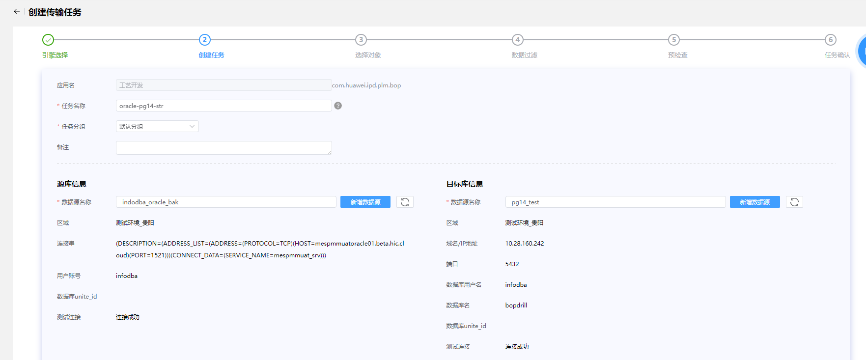

## 添加schema列表或者Table列表（数据搬迁）

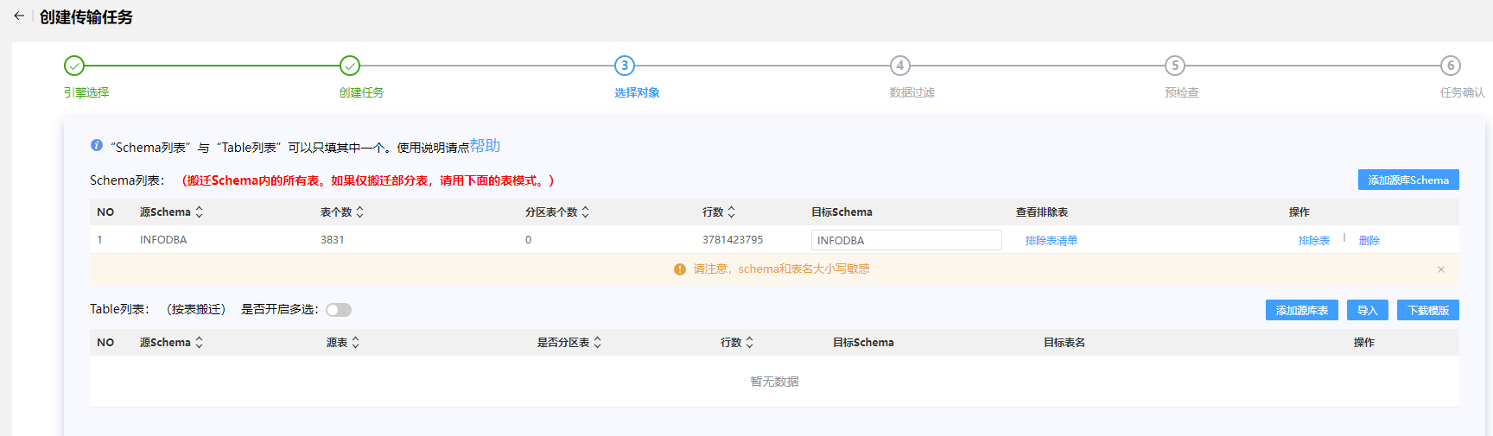

排除表（MMV_SPATIAL_CELL_INDEX、TEMP_SESSION、TEMP_SESSION_0618、TEMP_SESSION_0619_1）

## 数据过滤

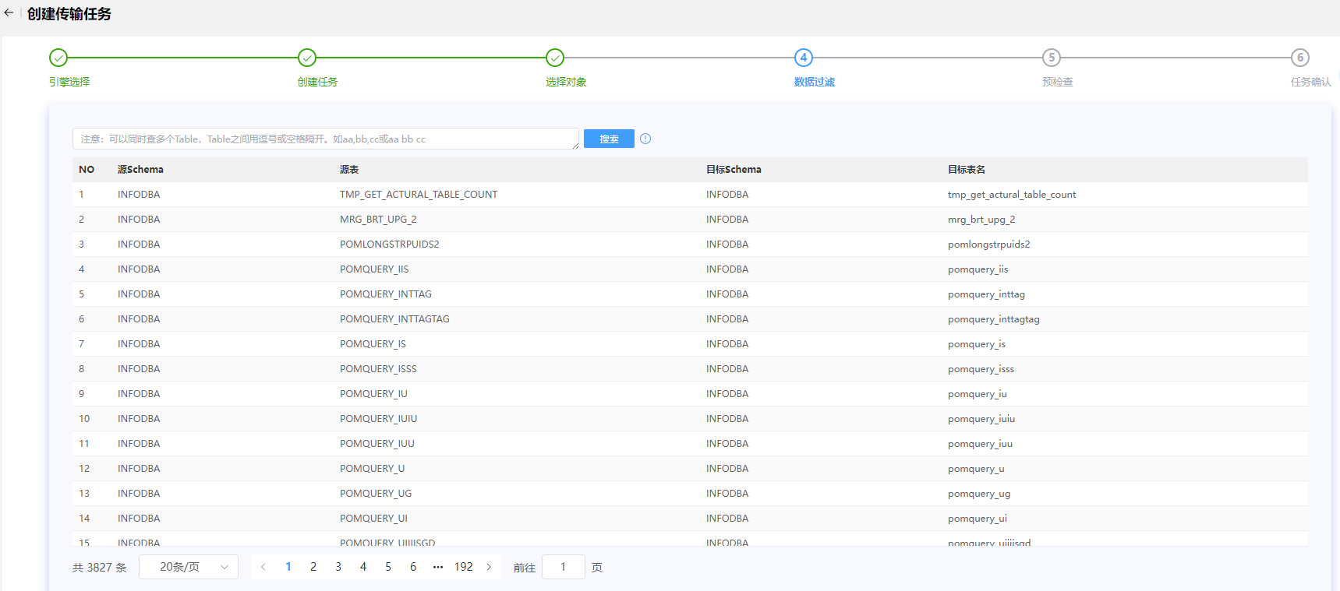

## 预检查

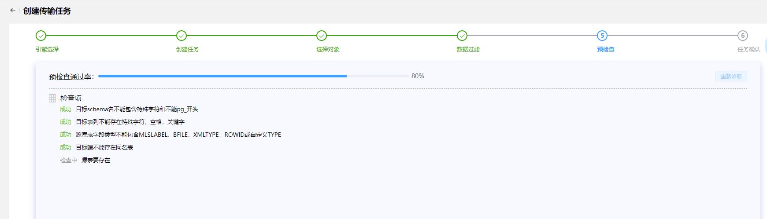

## 任务确认

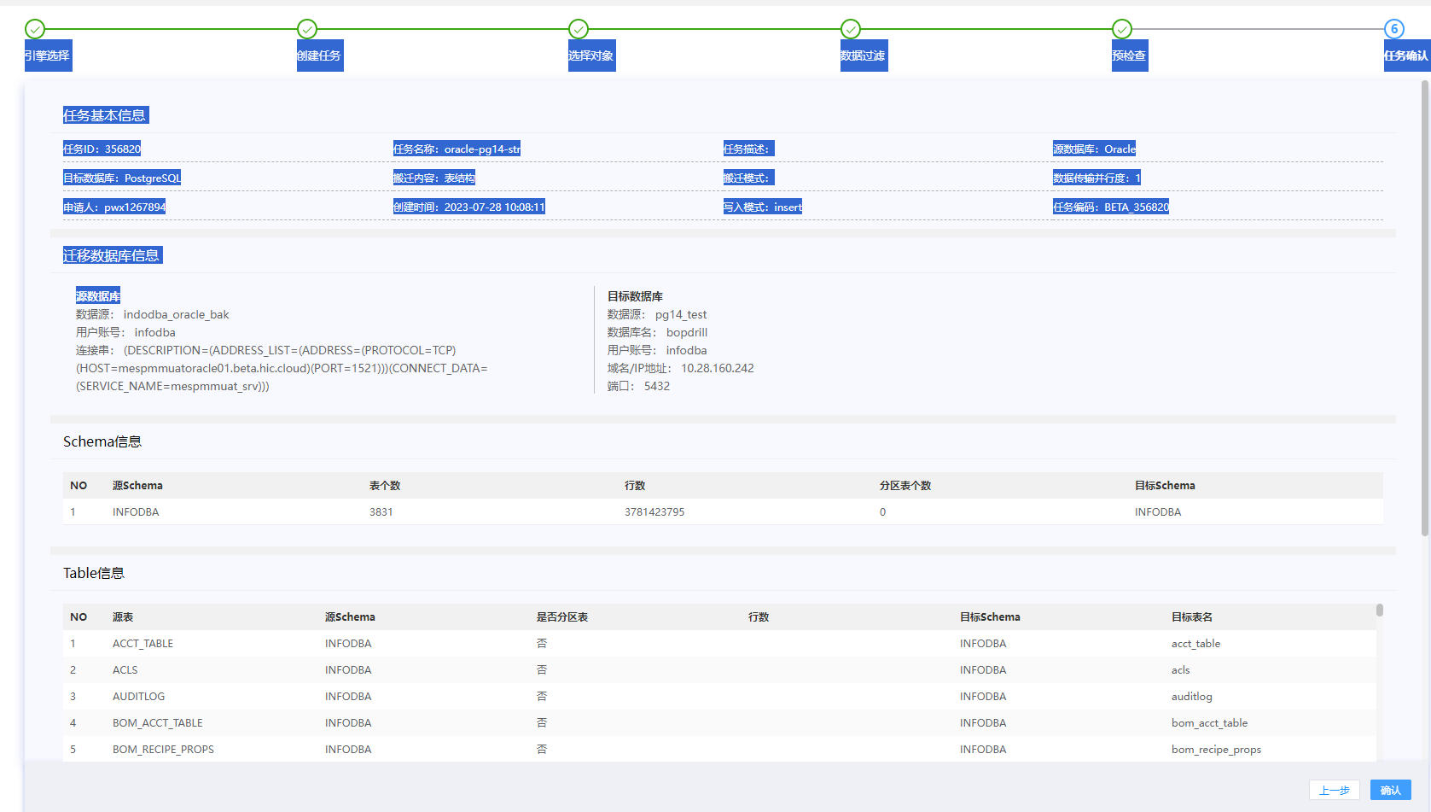

时长：26分

## 新建排除4张的表结构

create table MMV_SPATIAL_CELL_INDEX

(

puid VARCHAR(15) not null,

spatial_rep VARCHAR(15) not null,

cell_id INTEGER not null,

occ_path_prefix VARCHAR(900) not null,

occ_path_suffix VARCHAR(4000),

pxmin numeric,

ymin numeric,

zmin numeric,

pxmax numeric,

ymax numeric,

zmax numeric

);

create unique index MMVSPATIALCELLINDEX_PUID_PK on MMV_SPATIAL_CELL_INDEX (PUID);

create index MMV_SPATIAL_CELLID1 on MMV_SPATIAL_CELL_INDEX (CELL_ID);

create index MMV_SPATIAL_OCCPATHPREFIX1 on MMV_SPATIAL_CELL_INDEX (OCC_PATH_PREFIX);

create index MMV_SPATIAL_SPATIALREP1 on MMV_SPATIAL_CELL_INDEX (SPATIAL_REP);

create table TEMP_SESSION

(

id numeric,

exetime DATE,

sid numeric,

"serial#" numeric,

process VARCHAR(24),

machine VARCHAR(64),

program VARCHAR(48),

osuser VARCHAR(30),

status VARCHAR(8),

prev_sql_id VARCHAR(24),

sql_id VARCHAR(24)

);

create table TEMP_SESSION_0618

(

id numeric,

exetime DATE,

sid numeric,

"serial#" numeric,

process VARCHAR(24),

machine VARCHAR(64),

program VARCHAR(48),

osuser VARCHAR(30),

status VARCHAR(8)

);

create table TEMP_SESSION_0619_1

(

id numeric,

exetime DATE,

sid numeric,

"serial#" numeric,

process VARCHAR(24),

machine VARCHAR(64),

program VARCHAR(48),

osuser VARCHAR(30),

status VARCHAR(8),

prev_sql_id VARCHAR(24),

sql_id VARCHAR(24)

);

## 导入四张表的数据，MMV_SPATIAL_CELL_INDEX、TEMP_SESSION、TEMP_SESSION_0618、TEMP_SESSION_0619_1 （flashsync)

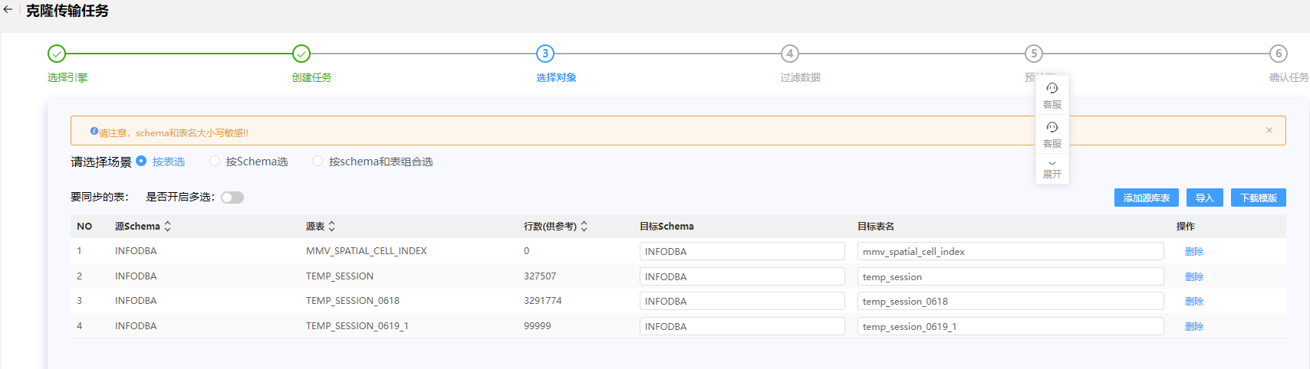

## 导入所有表的数据除MMV_SPATIAL_CELL_INDEX、TEMP_SESSION、TEMP_SESSION_0618、TEMP_SESSION_0619_1 （flashsync)。

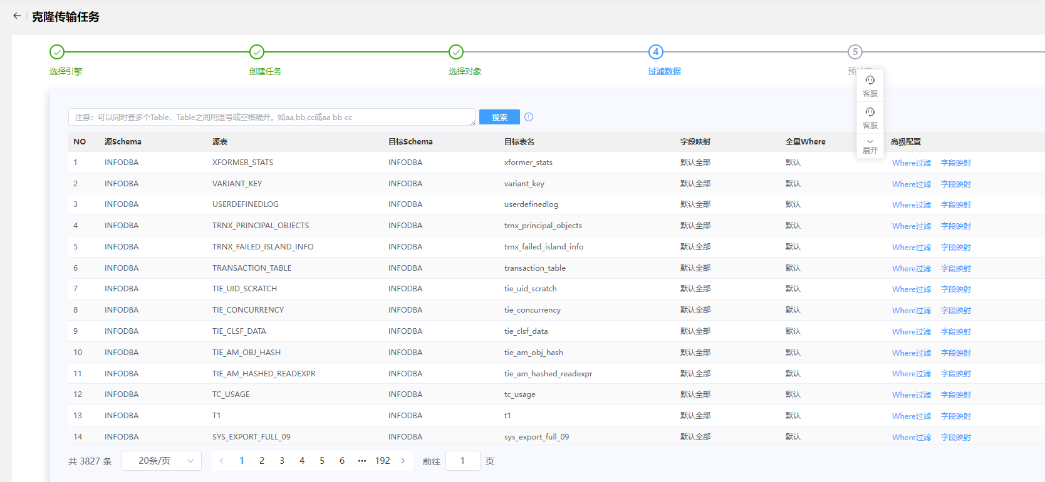

索引重建报错：rebuild index piph6specialoperationreq_0 error,error:index row size 2808 exceeds btree version 4 maximum 2704 for index "piph6specialoperationreq_0" DETAIL: Index row references tuple (8386,36) in relation "ph6specialoperationreq". HINT: Values larger than 1/3 of a buffer page cannot be indexed. Consider a function index of an MD5 hash of the value, or use full text indexing.

解决方案：

create extension pg_trgm;

create index ph6specialoperationreq_0 on ph6specialoperationreq using gin (PVAL_0 gin_trgm_ops);

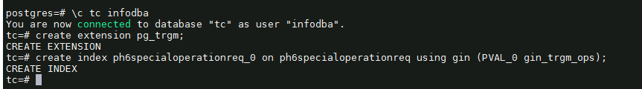

安装插件create extension pg_trgm;报错信息是extenction文件目录中缺少control文件。应该是编译信息没有遍全

( tar -zxvf postgresql-14.8.tar.gz -C /app/install

cd /app/install/postgresql-14.8

./configure –prefix=/app/postgresql

make world && make install-world)

再然后在flashsync,目标表索引重建详情 选择状态 “已失败”，点击“重试”

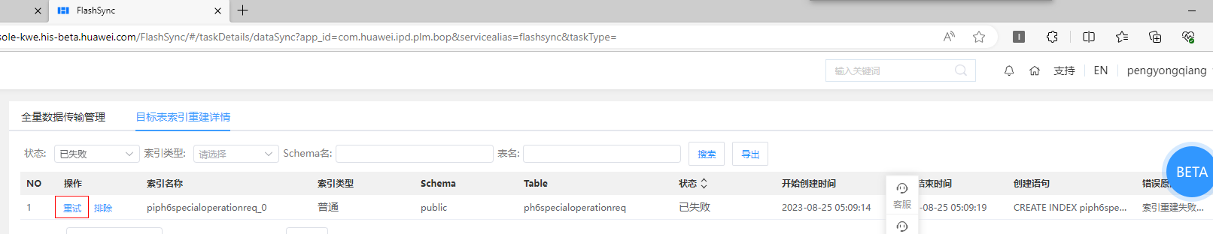

# 对比表数据

Oracle:

select count(*) from user_tables; 4001

Pg14:

SELECT COUNT(*) AS table_count

FROM information_schema.tables

WHERE table_schema = 'public' and table_type = 'BASE TABLE '; 4001

# 视图数据

Oracle:

Select count(*) from user_views; 284

Pg14:

SELECT table_name

FROM information_schema.views

WHERE table_schema = current_schema; 0

# 索引数据

oracle:

select index_name as indexname from user_indexes i where i.index_name not like 'SYS_%'; 6914

pg:

select upper(indexname) from pg_indexes where schemaname = 'public' and indexname not like 'sys_%'; 6924

oracle导出xls表，然后导入PG tc库里表名为t1比较

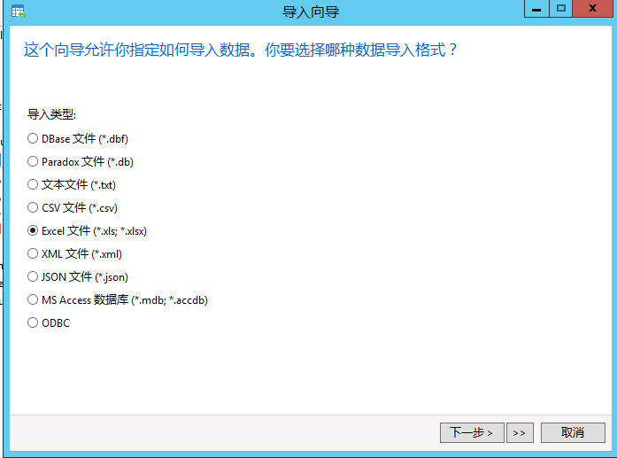

Select * from t1

except

select upper(indexname) from pg_indexes where schemaname = 'public' and indexname not like ' sys_%'; 结果为

PIPH6SPCIALOPERATIONREQ_0 显示没有建此索引。



这个索引已建

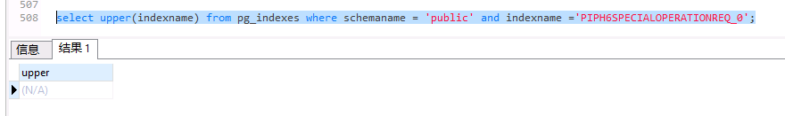

# 序列数据

oracle:

SELECT count(*) FROM user_sequences; 318

pg：

SELECT count(*)

FROM information_schema.sequences

WHERE sequence_schema = current_schema; 0

# 数据量的检查

1）在oracle数据库中执行：

-------------------------------------------------------------------------------

create table TMP_GET_ACTURAL_TABLE_COUNT(table_name varchar(50),table_cnt int);

select * from TMP_GET_ACTURAL_TABLE_COUNT;

CREATE OR REPLACE PROCEDURE GET_ACTURAL_TABLE_COUNT(isrun integer) AUTHID CURRENT_USER IS

cursor_sql SYS_REFCURSOR;

record_count number;

BEGIN

FOR cursor_sql IN (SELECT table_name FROM user_tables ) LOOP

EXECUTE IMMEDIATE 'SELECT COUNT(*) FROM ' || cursor_sql.table_name INTO record_count;

INSERT INTO TMP_GET_ACTURAL_TABLE_COUNT (table_name, table_cnt) VALUES (cursor_sql.table_name, record_count);

COMMIT;

END LOOP;

COMMIT;

END;

/

truncate table TMP_GET_ACTURAL_TABLE_COUNT;

call GET_ACTURAL_TABLE_COUNT(1);

commit;

-------------------------------------------------------------------------------

2）在postgresql数据库中执行。

-------------------------------------------------------------------------------

create table TMP_GET_ACTURAL_TABLE_COUNT(table_name varchar(50),table_cnt bigint);

CREATE OR REPLACE PROCEDURE GET_ACTURAL_TABLE_COUNT(isrun integer)

language plpgsql

AS $$

declare

table_count bigint;

cursor_sql record;

begin

for cursor_sql in(

select table_name from information_schema.tables where table_schema='public' and table_type ='BASE TABLE'

) loop

execute 'SELECT COUNT(*) FROM ' || cursor_sql.table_name INTO table_count;

insert into TMP_GET_ACTURAL_TABLE_COUNT(table_name,table_cnt) values(cursor_sql.table_name,table_count);

commit;

end loop;

end;

$$;

truncate table TMP_GET_ACTURAL_TABLE_COUNT;

/

call GET_ACTURAL_TABLE_COUNT(1);

/

select * from TMP_GET_ACTURAL_TABLE_COUNT;

-------------------------------------------------------------------------------

在postgresql创建外部表指向oracle数据库的TMP_GET_ACTURAL_TABLE_COUNT，并在postgresql库中比较相同表名的数据量的差异。

# 第四部分 oracle数据库迁移约束、序列、视图、过程、函数、触发器、包到PG

# oracle数据库迁移约束

Vi ora2pg.conf

--修改内容如下

TYPE TABLE

ora2pg -c /data01/soft_tar/export_dir/ora2pg.conf -o /data01/soft_tar/export_dir/test1/output.sql > /data01/soft_tar/export_dir/test1/output.sql.log

产生的 output.sql 文件用 table_split.pl 处理下，将table的创建语句和constraint，index的创建语句分开。

table_split.pl 内容如下

----------------------------------------------------------------------------------------------------------------------

open(INPUT, "output.sql");

open(OUTPUT, ">", "table.sql");

open(OUTPUT2, ">", "constraints.sql");

open(OUTPUT3, ">", "index.sql");

while(<INPUT>){

$str.=$_

}

@index=$str=~/CREATE\s*(?:UNIQUE)?\s*INDEX\s+\w+\s+ON[^\n]*;\n/igm;

@constraint=$str=~/ALTER\s*TABLE[^\n]*;\n/igm;

$str=~s/CREATE\s*(?:UNIQUE)?\s*INDEX\s+\w+\s+ON[^\n]*;\n//igm;

$str=~s/ALTER\s*TABLE[^\n]*;\n//igm;

print OUTPUT3 @index;

print OUTPUT2 @constraint;

运行 perl table_split.pl

导入约束

psql -U infodba -d tc -f constraints.sql > constraints_output.log 2>&1

grep ‘psql’ constraints_output.log

psql:constraints.sql:53:ERROR:cannot alter system column “xmin”

psql:constraints.sql:56:ERROR:cannot alter system column “xmin”

psql:constraints.sql:7127:ERROR: multiple primary keys for table “pom_lock_keys”

(alter table pom_lock_keys add primary key(puid); ) –主键创造多次，可以忽略。

alter table mmv_spatial_cell_index alter column pxmin set not null;

alter table mmv_spatial_cell_index alter column pxmax set not null;

# oracle数据库迁移序列

Vi ora2pg.conf

--修改内容如下

TYPE SEQUENCE

ora2pg -c /data01/soft_tar/export_dir/ora2pg.conf -o /data01/soft_tar/export_dir/test1/sequence.sql > /data01/soft_tar/export_dir/test1/sequence.sql.log

导入

Vi sequence.sql

把创建和设置schema删除。因为序列创建到public

psql -U infodba -d tc -f sequence.sql > sequence_output.log 2>&1

检查：grep 'psql' sequence_output.log

查看oracle序列个数：select count(*) from user_sequences; 318

查看PG序列个数：select count(*) from information_schema.sequences where sequence_schema =CURRENT_SCHEMA; 318

# oracle数据库迁移视图

Vi ora2pg.conf

--修改内容如下

TYPE VIEW

ora2pg -c /data01/soft_tar/export_dir/ora2pg.conf -o /data01/soft_tar/export_dir/test1/view.sql > /data01/soft_tar/export_dir/test1/view.sql.log

导入

psql -U infodba -d tc -f view.sql > view_output.log 2>&1

grep “psql” view_output.log

psql:view.sql:744: ERROR: function lpad(bigint,integer,unknown) does not exist

psql:view.sql:892: ERROR: function lpad(bigint,integer,unknown) does not exist

psql:view.sql:1116: ERROR: function lpad(bigint,integer,unknown) does not exist

解决方案：

CREATE OR REPLACE FUNCTION pg_catalog.lpad(bigint, integer, varchar)

RETURNS text

LANGUAGE sql

IMMUTABLE STRICT

AS $function$

SELECT pg_catalog.lpad($1::text, $2, $3::text)

$function$

查看oracle视图数量：select count(*) from user_views; 284

查看pg视图数量：select count(*) from information_schema.views where table_schema = CURRENT_SCHEMA; 281

----有相差3个对比一下

Oracle：select view_name as table_name from user_views;

把它导入pg，表名为t1

Pg: select upper(table_name) from information_schema.views where table_schema ='public';

Select * from t1

Except

select upper(table_name) from information_schema.views where table_schema ='public';

结果为

VL10N_EINFO

VL10N_VALUE

VL10N_AWP0CONTENTNAMS

CREATE

OR REPLACE VIEW VL10N_EINFO AS SELECT

puid,

SUBSTR( pval_0, 1, 5 ) AS locale,

SUBSTR( pval_0, 7, 1 ) AS preference,

SUBSTR( pval_0, 9, 1 ) AS status,

SUBSTR( pval_0, 11, 4 ) AS sequence_no,

SUBSTR( pval_0, 49, 240 ) AS pval_0

FROM

PL10N_EINFO UNION ALL

SELECT

PEINFO.puid,

'NONE' AS locale,

'M' AS preference,

'M' AS status,

lpad( pseq, 4, '0' ) AS sequence_no,

pval_0

FROM

PEINFO,

PICML

WHERE

PICML.puid = PEINFO.puid

AND PICML.VLA_487_5 = 0;

CREATE

OR REPLACE VIEW VL10N_VALUE AS SELECT

puid,

SUBSTR( pval_0, 1, 5 ) AS locale,

SUBSTR( pval_0, 7, 1 ) AS preference,

SUBSTR( pval_0, 9, 1 ) AS status,

SUBSTR( pval_0, 11, 4 ) AS sequence_no,

SUBSTR( pval_0, 49, 256 ) AS pval_0

FROM

PL10N_VALUE UNION ALL

SELECT

PVALUE.puid,

'NONE' AS locale,

'M' AS preference,

'M' AS status,

lpad( pseq, 4, '0' ) AS sequence_no,

pval_0

FROM

PVALUE,

PSTXT

WHERE

PSTXT.puid = PVALUE.puid

AND PSTXT.VLA_491_19 = 0;

CREATE

OR REPLACE VIEW VL10N_AWP0CONTENTNAMES AS SELECT

puid,

SUBSTR( pval_0, 1, 5 ) AS locale,

SUBSTR( pval_0, 7, 1 ) AS preference,

SUBSTR( pval_0, 9, 1 ) AS status,

SUBSTR( pval_0, 11, 4 ) AS sequence_no,

SUBSTR( pval_0, 49, 128 ) AS pval_0

FROM

PL10N_AWP0CONTENTNAMES UNION ALL

SELECT

PAWP0CONTENTNAMES.puid,

'NONE' AS locale,

'M' AS preference,

'M' AS status,

lpad( pseq, 4, '0' ) AS sequence_no,

pval_0

FROM

PAWP0CONTENTNAMES,

PAWP0TILETEMPLATE

WHERE

PAWP0TILETEMPLATE.puid = PAWP0CONTENTNAMES.puid

AND PAWP0TILETEMPLATE.VLA_1310_9 = 0;

# oracle数据库迁移过程

Vi ora2pg.conf

--修改内容如下

TYPE PROCEDURE

ora2pg -c /data01/soft_tar/export_dir/ora2pg.conf -o /data01/soft_tar/export_dir/test1/procedure.sql > /data01/soft_tar/export_dir/test1/procedure.sql.log

导入

psql -U infodba -d tc -f procedure.sql > procedure_output.log 2>&1

grep ‘psql’ procedure_output.log

psql:procedure.sql:59:ERROR: syntax error at or near “dbms_stats”

9.5函数

Vi ora2pg.conf

--修改内容如下

TYPE FUNCTION

ora2pg -c /data01/soft_tar/export_dir/ora2pg.conf -o /data01/soft_tar/export_dir/test1/function.sql > /data01/soft_tar/export_dir/test1/function.sql.log

导入 (注意把schema修改去掉)

psql -U infodba -d infodba_test -f function.sql > function_output.log 2>&1

psql:procedure.sql:59 ERROR：syntax error at or near”dbms_stats”

CREATE OR REPLACE PROCEDURE tc_indexer_proc () AS $body$

BEGIN

dbms_stats.gather_schema_stats(ownname=>'infodba', estimate_percent=>100, method_opt=>'FOR ALL COLUMNS SIZE AUTO', degree=>32, cascade=>true, no_invalidate=>FALSE);

END;

$body$

LANGUAGE PLPGSQL

SECURITY DEFINER

;

存储过程tc_indexer_proc ()导入报错。 --记录，这个oracle特性。

# oracle数据库迁移函数

Vi ora2pg.conf

--修改内容如下

TYPE FUNCTION

ora2pg -c /data01/soft_tar/export_dir/ora2pg.conf -o /data01/soft_tar/export_dir/test1/function.sql > /data01/soft_tar/export_dir/test1/function.sql.log

导入（注意把schema删除）

psql -U infodba -d tc -f function.sql > function_output.log 2>&1

grep ‘psql’ function_output.log

psql:function.sql:81:ERROR:syntax error at or near “is” ---此函数初始化里有，直接复制初始化库的。

# oracle数据库迁移触发器

Vi ora2pg.conf

--修改内容如下

TYPE TRIGGER

ora2pg -c /data01/soft_tar/export_dir/ora2pg.conf -o /data01/soft_tar/export_dir/test1/trigger.sql > /data01/soft_tar/export_dir/test1/trigger.sql.log

导入

psql -U infodba -d tc -f trigger.sql > trigger_output.log 2>&1

报错



触发器有100个，原生PG不支持，是不是使用，因为初始化库触发器。

# oracle数据库迁移包

Vi ora2pg.conf

--修改内容如下

TYPE PACKAGE

ora2pg -c /data01/soft_tar/export_dir/ora2pg.conf -o /data01/soft_tar/export_dir/test1/package.sql > /data01/soft_tar/export_dir/test1/package.sql.log

导入

psql -U infodba -d tc -f package.sql > package_output.log 2>&1

# oracle迁移数据库与初始化库int字段类型对比

# 1.导出所有int字段

PG：select table_name,column_name,data_type,udt_name from information_schema.columns where table_schema = 'public' and udt_name like 'int%';

**2.oracle迁移到PG的字段int，导入表名为oracle**

select table_name,column_name,data_type,udt_name from information_schema.columns where table_schema = 'public' and udt_name like 'int%';

**3.PG初始化的数据库的字段int，导入表名为pgi**

select table_name,column_name,data_type,udt_name from information_schema.columns where table_schema = 'public' and udt_name like 'int%';

**4.Oracle迁移到PG与PG初始化相同的int字段**

Select table_name,column_name,data_type,udt_name from pgi

Intersect

Select table_name,column_name,data_type,udt_name from oracle;

**5.Oracle迁移到PG与PG初始化不同的int字段**

select oracle.table_name,oracle.column_name,oracle.data_type,oracle.udt_name,pgi.data_type as pg_type, pgi.udt_name as pg_udt from oracle,pgi

where oracle.table_name=pgi.table_name and oracle.column_name = pgi.column_name and (oracle.data_type !=pgi.data_type or oracle.udt_name != pgi.udt_name);

总结：1）int类型，只有一条相同的int4

2）int类型有条相同其它都不同，从oracle迁移过来都是int8，初始化int4多，int2少。 3）基本上int不同。

# 第六部分 oracle迁移的数据库与初始化数据库比较

# 表的迁移

Pg:init表名

Select table_name from information_schema.tables where table_schema='public' and table_type ='BASE TABLE'; 3948

Pg:oracle表名：

Select table_name from information_schema.tables where table_schema='public' and table_type ='BASE TABLE'; 4002

select * from dblink('dbname=tc_test','Select table_name from information_schema.tables where table_schema= ''public'' and table_type =''BASE TABLE''') as t(table_name varchar(50))

except

select * from dblink('dbname=tc','Select table_name from information_schema.tables where table_schema=''infodba'' and table_type =''BASE TABLE''') as t(table_name varchar(50));

在初始化库上有的表，oracle中没有的14

pg_dump -s -t pfndoimpactingobjects -f output_file.sql tc_test

psql -U infodba -d tc -f output_file.sql > output.log 2>&1

grep 'psql' output.log

(初始化的函数先创建

lock_keys_deltete_trigger_func、lock_keys_insert_trigger_func）

# 索引迁移

Pg:oracle索引名

Select indexname from pg_indexes where schemaname='public' and indexname not like 'sys_%'; 6945

Pg:init索引名

Select indexname from pg_indexes where schemaname='public' and indexname not like 'sys_%'; 6884

select * from dblink('dbname=tc_test','select indexname from pg_indexes where schemaname=''public'' and indexname not like ''sys_%''') as t(table_name varchar(100))

except

select * from dblink('dbname=tc','Select indexname from pg_indexes where schemaname=''public'' and indexname not like ''sys_%''') as t(table_name varchar(100));

在初始化库上有的索引，oracle中没有的 13

select * from pg_indexes where indexname in (用notep++填定索引名);

CREATE UNIQUE INDEX auditlog_puid_pk ON public.auditlog USING btree (puid);

CREATE UNIQUE INDEX pipfnd0effectivityexprblock_2 ON public.pfnd0effectivityexprblock USING btree ((

CASE arev_category

WHEN 48 THEN rfnd0affectedobjectu

WHEN 16 THEN rfnd0affectedobjectu

ELSE NULL::character varying

END));

CREATE UNIQUE INDEX pipfnd0variantexprblock_2 ON public.pfnd0variantexprblock USING btree ((

CASE arev_category

WHEN 48 THEN rfnd0affectedobjectu

WHEN 16 THEN rfnd0affectedobjectu

ELSE NULL::character varying

END));

CREATE INDEX piph6specialoperationreq_0 ON public.ph6specialoperationreq USING btree (pval_0);

CREATE INDEX pipimanrelation_4 ON public.pimanrelation USING btree (rsecondary_objectu);

CREATE INDEX pipimanrelation_9 ON public.pimanrelation USING btree (pfnd0copystableid);

CREATE UNIQUE INDEX pipqs_product_path_index_1 ON public.pqs_product_path_index USING btree (pchilditem, pproduct, pitempath);

CREATE INDEX pipqs_product_path_index_2 ON public.pqs_product_path_index USING btree (pproduct);

CREATE UNIQUE INDEX pipqs_product_path_index_3 ON public.pqs_product_path_index USING btree (pseq);

CREATE INDEX pipqs_product_path_index_4 ON public.pqs_product_path_index USING btree (plast_modified_date);

CREATE INDEX pitie_am_obj_hash_0 ON public.tie_am_obj_hash USING btree (object_uid, am_readexpr_hash);

CREATE UNIQUE INDEX pk_principal_obj_uid ON public.principal_obj_in_trans_table USING btree (transaction_id, principal_obj_uid);

CREATE UNIQUE INDEX pk_site_id ON public.export_to_site_table USING btree (transaction_id, site_id);

# 约束

# 序列

Pg：init序列 312

Select count(*) from information_schema.sequences where sequence_schema='public';

'select sequence_name from information_schema.sequences where sequence_schema= ''public'''

Pg:oracle序列318

select * from dblink('dbname=tc_test', 'select sequence_name from information_schema.sequences where sequence_schema= ''public''') as t(table_name varchar(100))

except

select * from dblink('dbname=tc', 'select sequence_name from information_schema.sequences where sequence_schema= ''public'''

) as t(table_name varchar(100)); 312说明序列没有相同名字

导出序列：pg_dump -U sequence_name -f output_file.sql database_name

psql -U infodba -d tc -f output_file.sql > output.log 2>&1

grep 'psql' output.log

# 视图的迁移

select count(*) from information_schema.views where table_schema = 'public';

select * from dblink('dbname=tc_test','select table_name from information_schema.views where table_schema = ''public''') as t(table_name varchar(100))

except

select * from dblink('dbname=tc',' select table_name from information_schema.views where table_schema = ''public''') as t(table_name varchar(100));

pg_dump -U infodba -d tc -t vl10n_fnd0instructions -s -f output_file.sql

psql -U infodba -d tc -f output_file.sql > output.log 2>&1

没有创建上的视图需要确认： user_ind_columns、user_tables、user_ind_expressions、

User_indexes、user_tab_columns、user_views

# 存储过程、函数、触发器

打开工具Navicat Premium，选择相应的库—函数。然后复制。

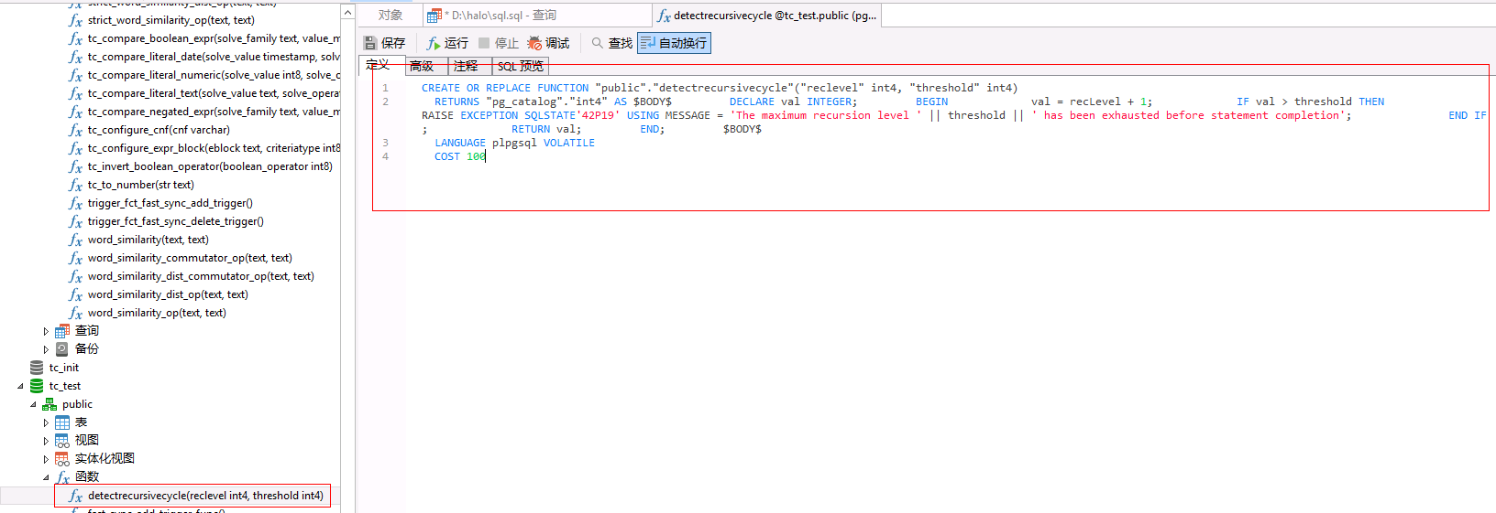

选择相应的库和schema，然后粘贴，再运行。

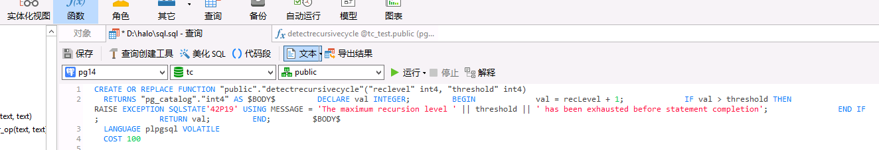

# 第七部分 验证数据

# 表结构的一致性-全量 ；验证

1. oracle表结构与oracle迁移到PG数据库的表结构比较;验证

Oracle：select table_name,column_name from user_tab_columns where column_id <> 0 and table_name not in(

select view_name from user_views) order by table_name,column_name;19144 

PG：select table_name,column_name from information_schema.columns where table_schema='public' and table_name not in(select table_name from information_schema.views) order by table_name,column_name; 19261 

Oracle:导入表名为oracle，pg:导入表名为pg

Select * from oracle

Except

Select upper(table_name),upper(column_name) from pg; 记录有2条

Table_name column_name

Mmv_spatial_cell_index xmax

Mmv_spatial_cell_index xmix

这两条导入就改了字段名。所以结论。Oracle库的表结构与迁移过来的表结构一样的。

1. oracle迁移到PG数据库与初始化库的一结构比较;验证;

PG：select table_name,column_name from information_schema.columns;

把数据导出

PGtoPG:

Select select pg.table_name,pg.column_name,pg.ordinal_position::int-1 from (select table_name,column_name,data_type,character_maximum_length,character_octet_length,numeric_precision_radix,numeric_scale,interval_type from pg where data_type not in ('double precision','integer','smallint')

except

select table_name,column_name,data_type,character_maximum_length,character_octet_length,numeric_precision_radix,numeric_scale,interval_type from oracle) as a,pg where a.table_name=pg.table_name and a.column_name=pg.column_name;

select b.table_name,b.column_name,pg.data_type,pg.character_octet_length,pg."column_name" from (select pg.table_name,pg.column_name,pg.ordinal_position::int - 1 as position from (select table_name,column_name,data_type,character_maximum_length,character_octet_length,numeric_precision_radix,numeric_scale,interval_type from pg where data_type not in ('double precision','integer','smallint')

except

select table_name,column_name,data_type,character_maximum_length,character_octet_length,numeric_precision_radix,numeric_scale,interval_type from oracle) as a,pg where a.table_name=pg.table_name and a.column_name=pg.column_name) as b,pg where b.table_name=pg.table_name and b.position=pg.ordinal_position::int order by ordinal_position;

表名：少列名

Ptc_project：pfnd0projectcategory

2：数据量的一致性-全量；验证

1）在oracle数据库中执行：

oracle

create table TMP_GET_ACTURAL_TABLE_COUNT(table_name varchar(50),table_cnt int);

select * from TMP_GET_ACTURAL_TABLE_COUNT;

CREATE OR REPLACE PROCEDURE GET_ACTURAL_TABLE_COUNT(isrun integer) AUTHID CURRENT_USER IS

cursor_sql SYS_REFCURSOR;

record_count number;

BEGIN

FOR cursor_sql IN (SELECT table_name FROM user_tables ) LOOP

EXECUTE IMMEDIATE 'SELECT COUNT(*) FROM ' || cursor_sql.table_name INTO record_count;

INSERT INTO TMP_GET_ACTURAL_TABLE_COUNT (table_name, table_cnt) VALUES (cursor_sql.table_name, record_count);

COMMIT;

END LOOP;

COMMIT;

END;

/

truncate table TMP_GET_ACTURAL_TABLE_COUNT;

call GET_ACTURAL_TABLE_COUNT(1);

commit;

2）在postgresql数据库中执行。

create table TMP_GET_ACTURAL_TABLE_COUNT(table_name varchar(50),table_cnt bigint);

CREATE OR REPLACE PROCEDURE GET_ACTURAL_TABLE_COUNT(isrun integer)

language plpgsql

AS $$

declare

table_count bigint;

cursor_sql record;

begin

for cursor_sql in(

select table_name from information_schema.tables where table_schema='public' and table_type ='BASE TABLE'

) loop

execute 'SELECT COUNT(*) FROM ' || cursor_sql.table_name INTO table_count;

insert into TMP_GET_ACTURAL_TABLE_COUNT(table_name,table_cnt) values(cursor_sql.table_name,table_count);

commit;

end loop;

end;

$$;

truncate table TMP_GET_ACTURAL_TABLE_COUNT;

/

call GET_ACTURAL_TABLE_COUNT(1);

/

select * from TMP_GET_ACTURAL_TABLE_COUNT;在postgresql创建外部表指向oracle数据库的TMP_GET_ACTURAL_TABLE_COUNT，并在postgresql库中比较相同表名的数据量的差异。

3：数据本身的一致性-抽查30% ；验证

4：数据编码的一致性-抽查30%;验证同上